## *Creating a Database Connection*

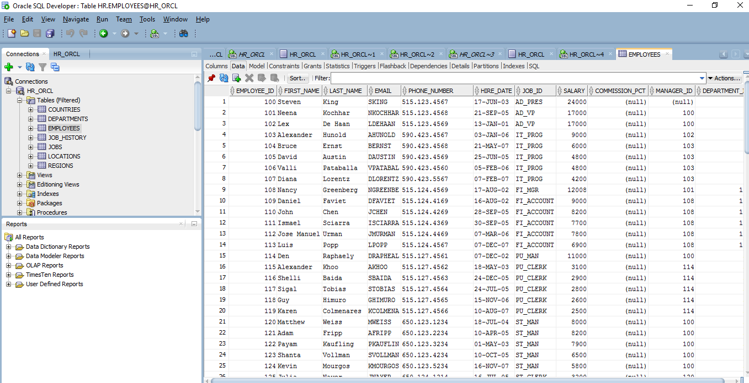

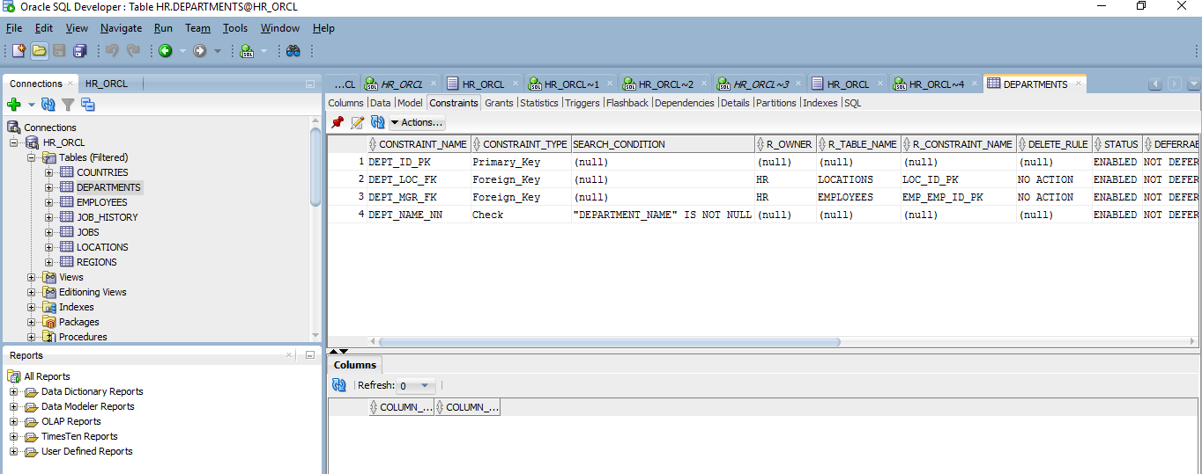

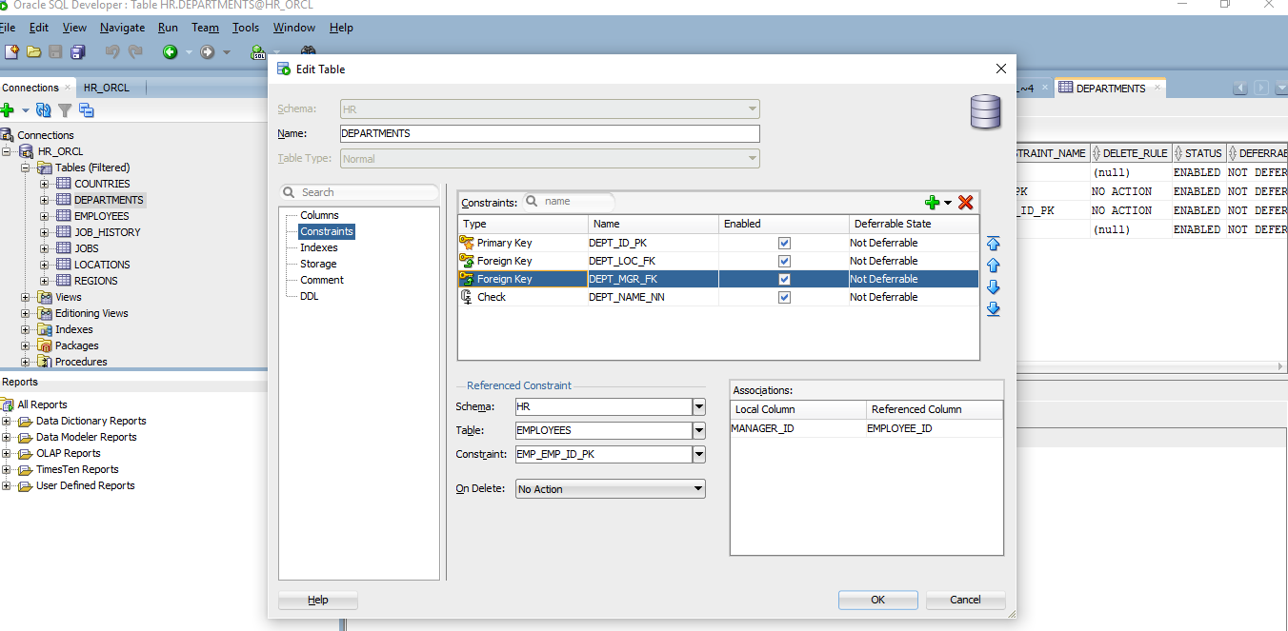

***Adding a New Table Using the Create Table Dialog Box***

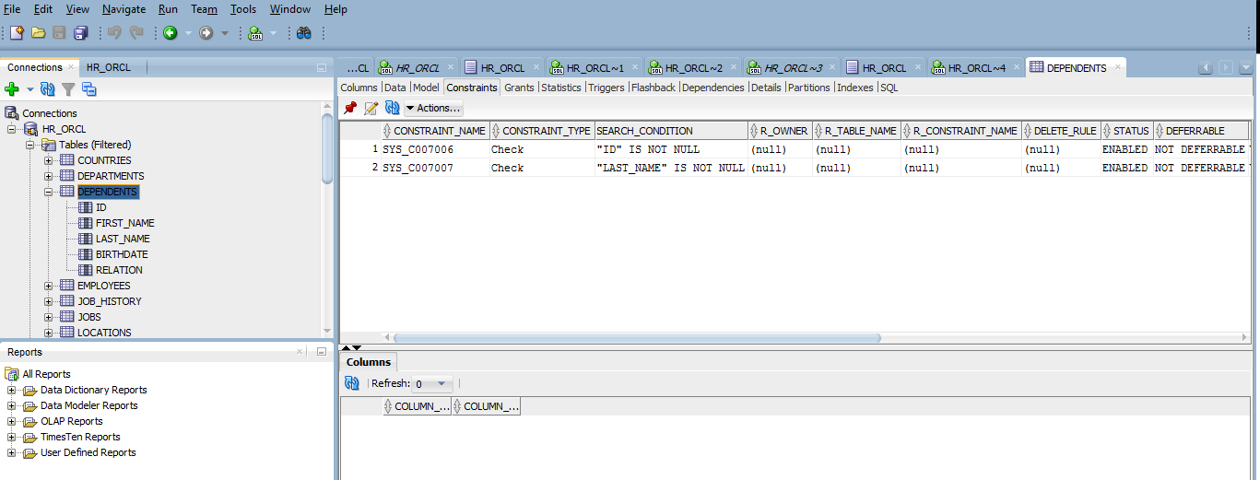

## 

## *Changing a Table Definition*

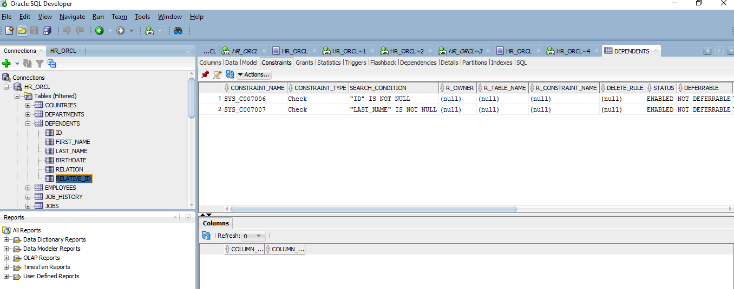

## *Adding Table Constraints*

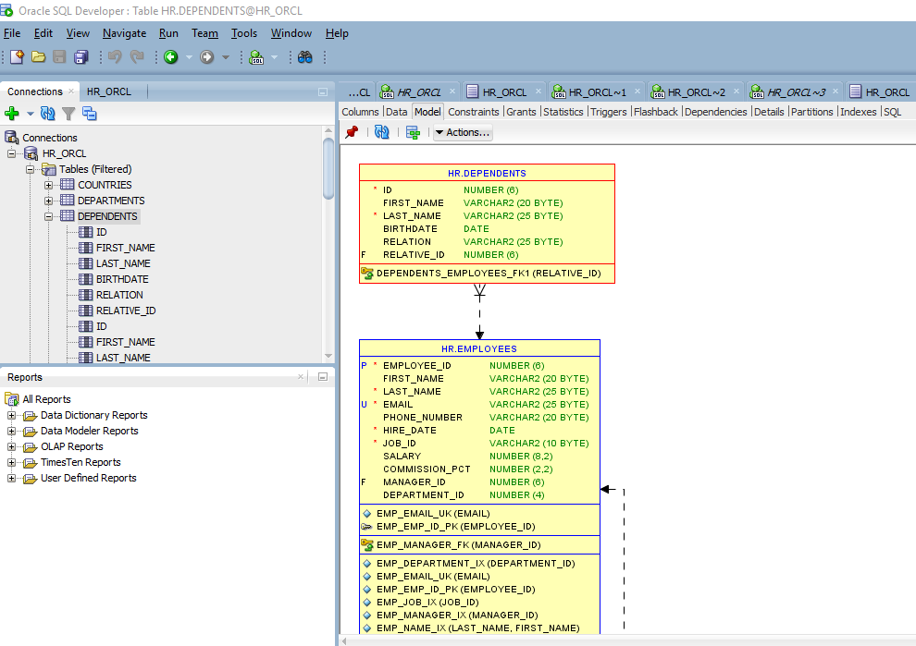

## 

## *Adding Data to a Table*

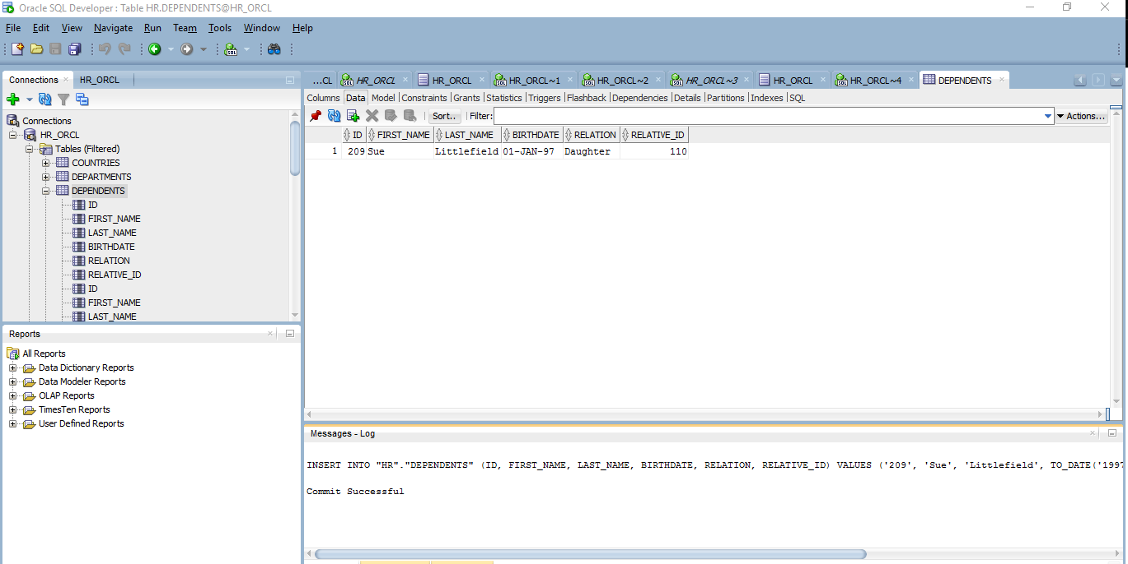

On my machine… Navigate to: C:\ProgramFiles\sqldeveloper\file\load_dep.sql

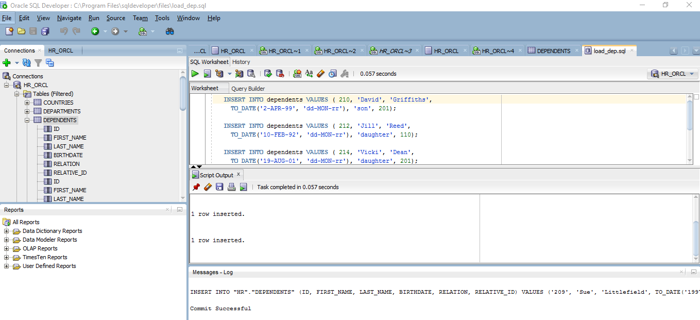

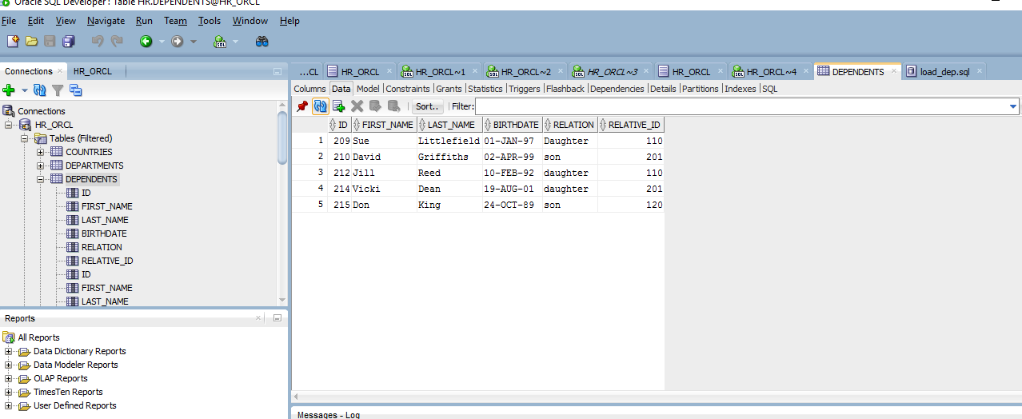

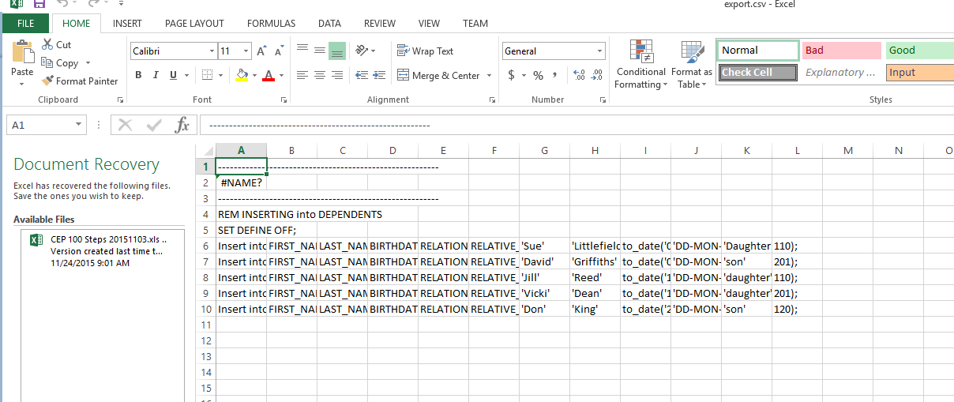

## 

## *Accessing Data*

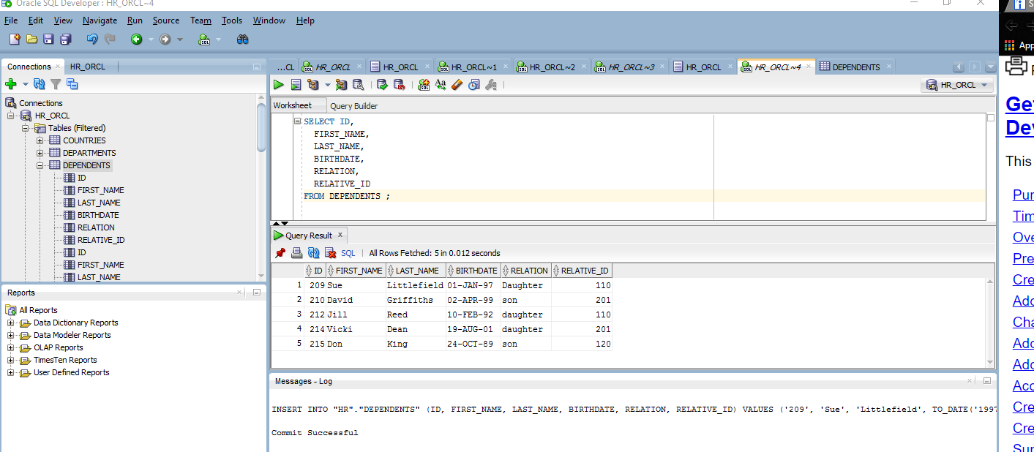

## *Creating Reports*

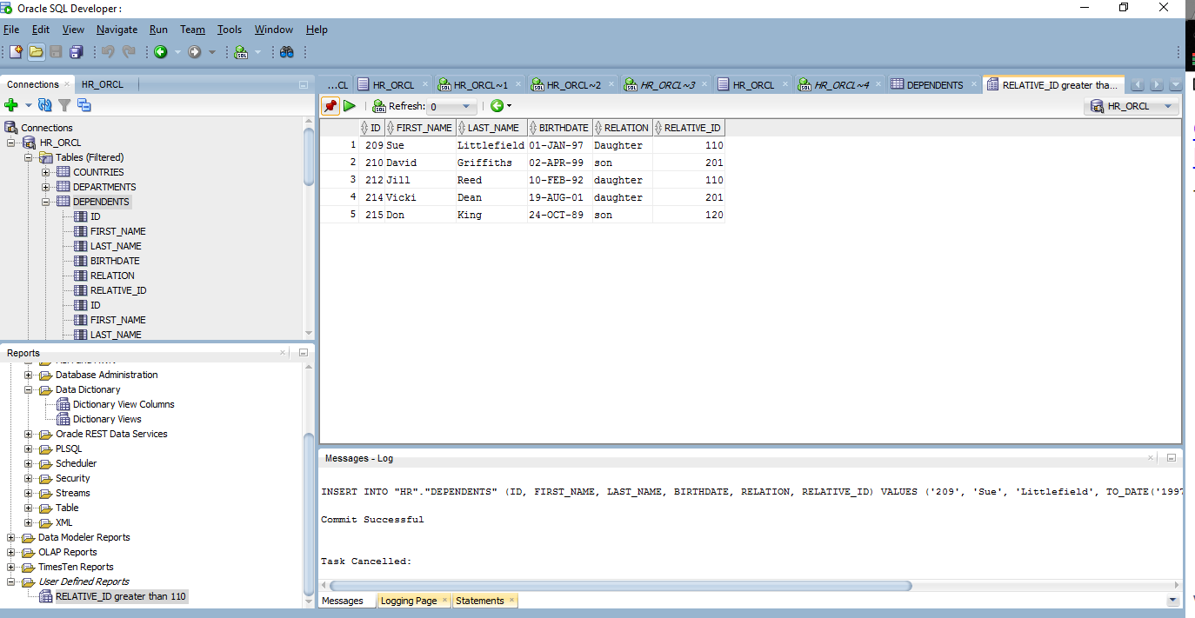

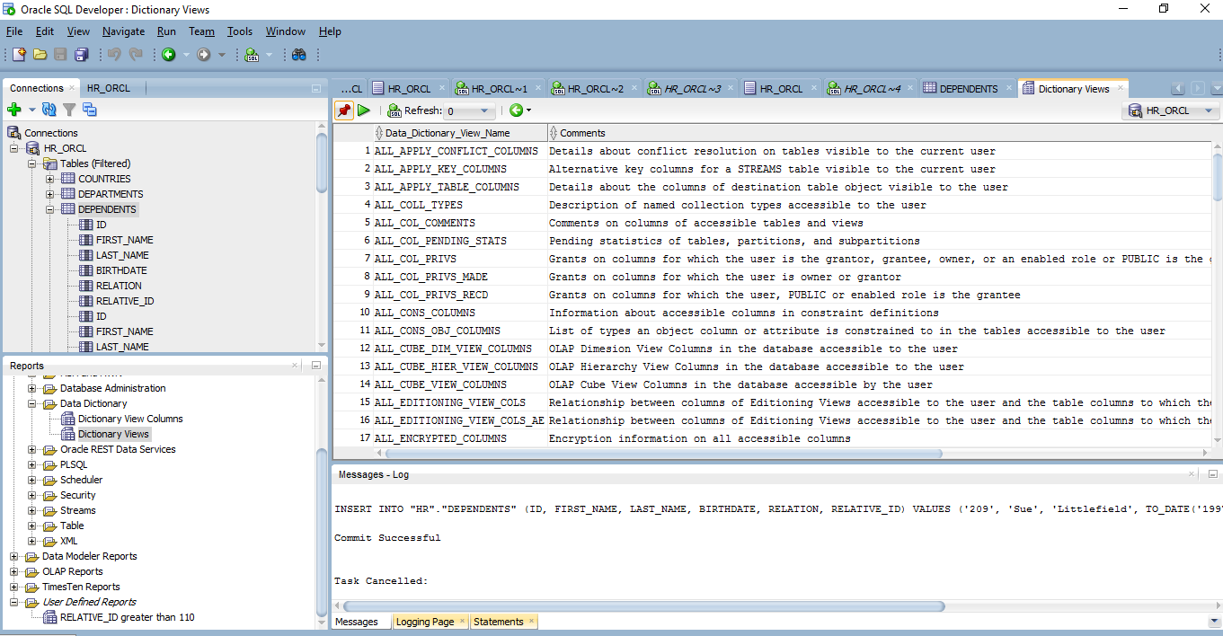

## *Creating and Executing PL/SQL*

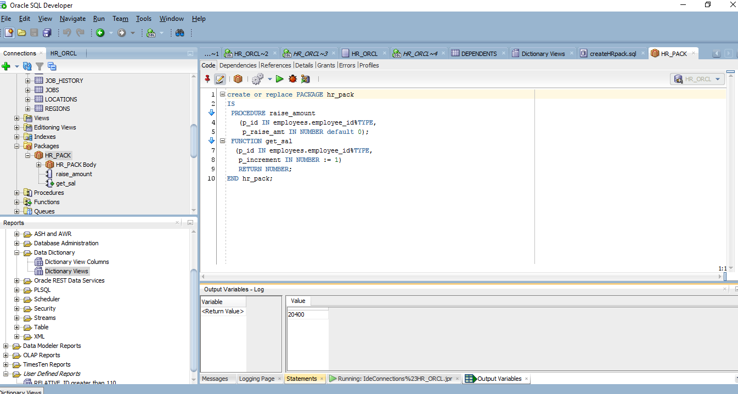

Exception handling with an out of range value (5 instead of 1.5)

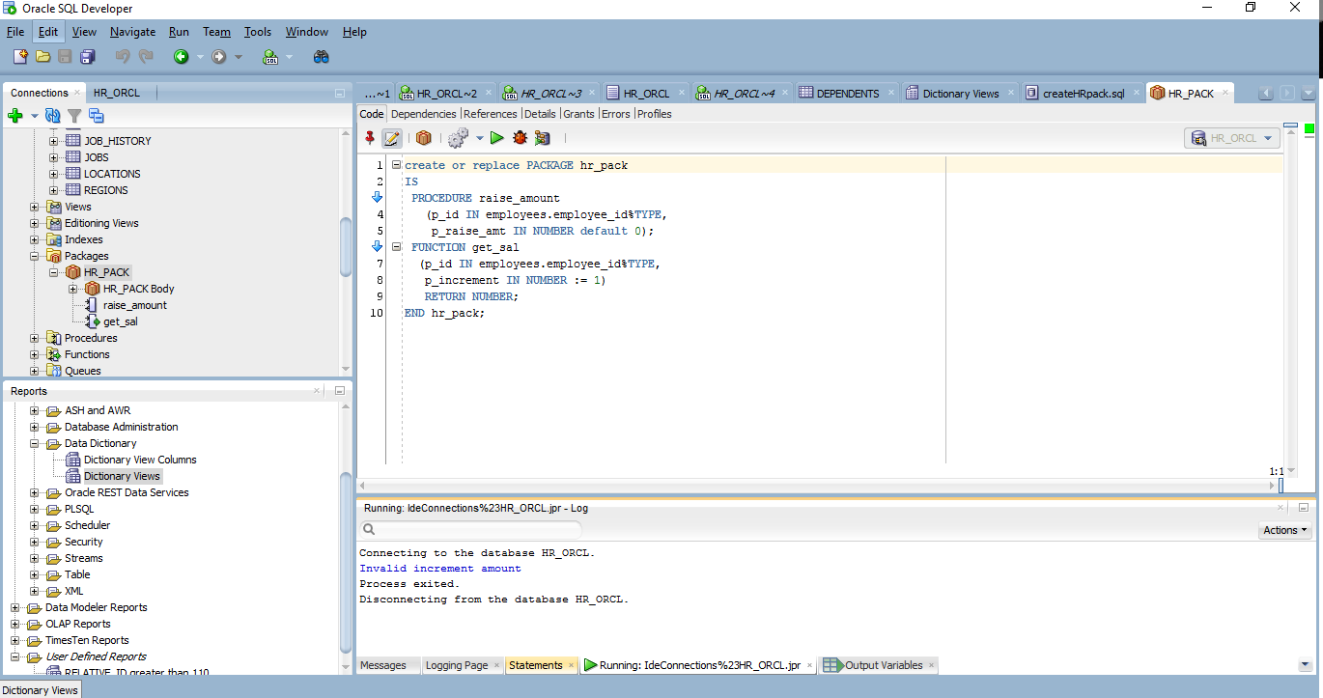

REFERENCE

Getting Started with Oracle SQL Developer 3.0. (n.d.). Retrieved January 21, 2016, from <http://www.oracle.com/webfolder/technetwork/tutorials/obe/db/sqldev/r30/sqldev3.0_GS> /sqldev3.0_GS.htm